
Brief Medical History Form
Insert your
logo here
(Pages 1–2 completed by client before or at time of service, page 3 completed by therapist)

Date: _______________

Name: _____________________________________________ DOB: __________________________

What is the reason why you are seeking help? ____________________________________________

____________________________________________________________________________________

Have you received manual lymphatic drainage before? Yes No

If yes, by whom: ______________________________________________________________________

What are your current symptoms/complaints? ___________________________________________

____________________________________________________________________________________

Have you had other therapies for the same symptoms/complaints? Yes No

If yes, please explain your experience, success, or lack of success:

____________________________________________________________________________________

What are your treatment goals? ________________________________________________________

____________________________________________________________________________________

Have you had any surgery? Yes No

If yes, list surgeries and dates: ___________________________________________________________

____________________________________________________________________________________

____________________________________________________________________________________

Have you had any cancer surgery? Yes No

If yes, where and when: ________________________________________________________________

____________________________________________________________________________________

Have you had any lymph nodes removed? Yes No

If yes, how many: _____________________________________________________________________

Have you ever received radiation therapy for cancer? Yes No

If yes, list area of radiation and dates here: _________________________________________________

____________________________________________________________________________________

Have you had chemotherapy? Yes No

If yes, how long ago?___________________________________________________________________

Have you had any infections (cellulitis)? Yes No

If yes, please explain: _________________________________________________________________

Do you have pain? Yes No

If yes, please explain: __________________________________________________________________

___________________________________________________________________________________

Do you have any loss of function or mobility? Yes No

If yes, please explain: __________________________________________________________________

____________________________________________________________________________________

Do you currently suffer from (or have you had) any of the following?
Asthma | Hyperthyroidism | Crohn’s Disease
Bronchitis | Kidney failure | Diverticulitis
Difficulties breathing | Diabetes | Recent abdominal surgery
Irregular heart beat | Infections (cellulitis) | Unexplained pain
Heart edema | Sleep apnea | Deep venous thrombosis (blood clot)
Hypertension | Malignancy (cancer) | Latex allergy
Swelling (edema)

Do you have any allergies? If yes, please explain: ___________________________________________________________________________________

Do you have any other medical problems not listed above? Yes No

If yes, please explain: _________________________________________________________________

Are you taking any medication? Yes No

If yes, list medications and amounts here: _________________________________________________

___________________________________________________________________________________

At the time you are completing this, are you pregnant or is there a chance you could be pregnant?

Yes No

Do you exercise regularly? Yes No

If yes, please describe: _________________________________________________________________

____________________________________________________________________________________

Is there anything else you would like to tell us at this time? _________________________________

____________________________________________________________________________________

Treatment Plan (This page is to be completed by therapist):
Reason for treatment: Contraindications/precautions:

General MLD to promote health Neck treatment
and relaxation / general detoxification
Abdominal Treatment
Post-surgical, post-traumatic
History of CHF, DVT, CKD
Lymphedema (also complete
lymphedema addendum) LN precautions ____________________
Other_________________________ Other____________________________

Indicate current findings and MLD sequence:

Key:
Edema (swelling):
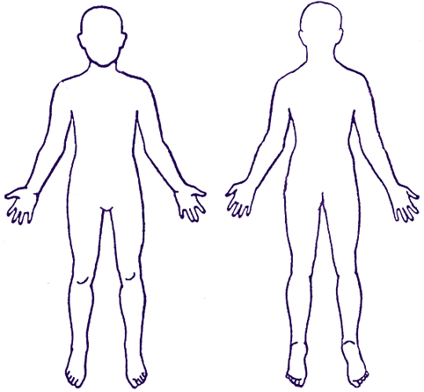
Scar(s):
Node removal: ♦
Radiation field (if applicable:
Tissue Tignes/fibrosis: ###
Numbness/tingling: ***
Pain: (0= no pain;
10= worst pain)

